Henning Larsen Shares Vision for Brouck’R, an Expansive Urban Transformation for Major Site in Brussels City Center
The design for the city block at Brussels’ bustling Place de Brouckère draws upon traditional and contemporary heritage to create a vibrant mixed-use destination for the city in the 21st century.
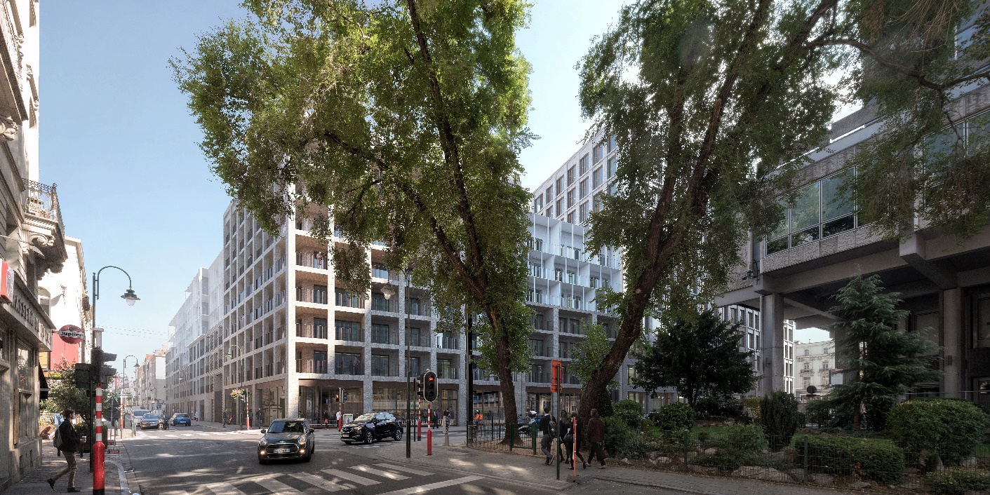

Henning Larsen has unveiled its vision for an urban transformation project facing Brussels’ bustling Place De Brouckère, bringing 48,000 m² of commercial, residential, hotel and green space to the Belgian capital. Developed in collaboration with Brussels-based studio a2rc and developers Immobel Group and BPI Real Estate, the scheme will expand the huge potential of the historical site, preserving the recognizable character of the area while introducing new communities for living and working.

Reclaiming an urban area formerly dominated by corporate offices, Brouck’R will unify city living and working in a single, central city block that opens onto the grand Place de Brouckère. The design for the block balances the architectural heritage of Brussels’s grand Belle Epoque structures with a contemporary approach to style and scale.

“Cities must be places where people can move freely and fluidly, finding personal ways to connect with the city around them,” explains Jacob Kurek, Henning Larsen Partner in charge of Brouck’R. “Brussels, while one of Europe’s oldest cities, has a rich urban fabric and thriving culture that makes it feel youthful. This, plus the city’s willingness to innovate and reinvent itself, makes this an incredibly exciting project to be involved in.”

Bringing Public Life Back to the Center

Place de Brouckère, located within the Brussels’ central Pentagon, was once a bustling pedestrian plaza but fell out of popular use as the city emphasized automobile and large-scale construction projects in the mid-20th century. The “Brusselization” of the city, as this growth came to be known, resulted in an urban core hollowed of residential spaces as many Brusselaars moved to the city’s outer neighborhoods.

Brouck’R expands on successful local efforts to pedestrianize and re-center civic life in Brussels’ urban core, wrapping an entire block with apartments and student accommodations at a scale largely unseen in the city center. The design comprises 311 new residences, divided between typical apartment and student-geared accommodations (see facts below.) The courtyard at the building’s center will be a green oasis for the residents, with gardens at the ground level and trellises/green walls that climb upwards along the south and west internal facades. Commercial and retail program, which makes up nearly a quarter of the development, will anchor the buildings at ground level.

“The whole concept behind the scheme for Brouck’R is to bring back its original energy, to bring back the things that have been lost in translation over the years,” says Kurek. “We see it less as a new development than as a revival of an exciting, forgotten heritage.”

Negotiating Heritage and the Future

Brouck’R’s four facades each face different urban conditions; the iconic row of 19th-century facades lining the Place de Brouckère will remain, fronting new construction behind. The remaining three façades will appear continuous, broken down into modules that change every 18-20 meters, an approach that links the design to walking pace, rather than at the speed of traffic.
A variety of brick construction types to reduce the scale of the massing. Looking up, the building’s upper floors will be clad in slim, light-colored material that visually marks not just a difference in program types but in living styles. Where the brick-clad apartments that comprise the bulk of the residential program visually link to the surrounding context, the block’s cloud-like top suggests a new outlook on urban life.
“Much in the same way Brussels tends to transform itself, our vision is about introducing accessibility, and permeability. The four elevations that face the street combine new design with existing architecture, with spaces in between offering glimpses into a green oasis at the center,” Kurek explains. “Offering pleasant views to those who populate the block, it is the calm flipside to and Scandinavian influence on the bustling urbanity at Place de Brouckère.”

Henning Larsen’s work often stretches between the architectural and urban scales, with similar projects underway in San Francisco’s Mission Rock development, the Etobicoke Civic Center and Plaza in Toronto, and the NØRR Saint Denis development in Paris. Brouck’R will rise in concert with Brussels’ expanding pedestrian zone, establishing a new community in the city center dedicated to street-level activity. Construction on Brouck’R is expected to commence in mid-2021 and reach completion in 2024.

18 February, 2020

Facts:
- Lead Architect: Henning Larsen Architects (Denmark)
- Local Architect: a2rc (Belgium)
- Developers: BPI Real Estate and Immobel

Programme: total 40,400 m²
- 182 apartments
- 129 student rooms
- Hotel with 145 rooms
- Office building of 8,840m²
- 3,220m² retail space

Planning (subject to the date of the final authorisation)
- Spring 2020 to end 2020: temporary use
- Autumn 2020: decommissioning works
- Beginning of 2021: start of demolition
- Summer 2021: start of construction
- Mid 2024: Estimated completion date

