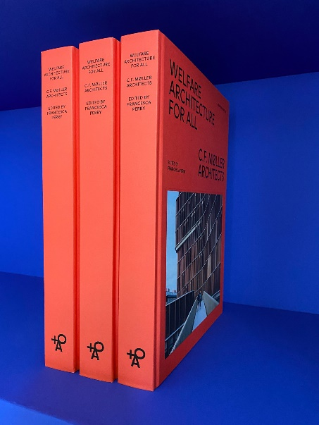
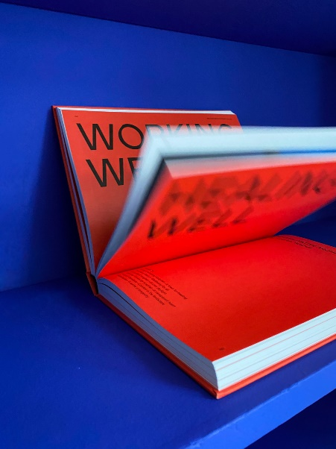
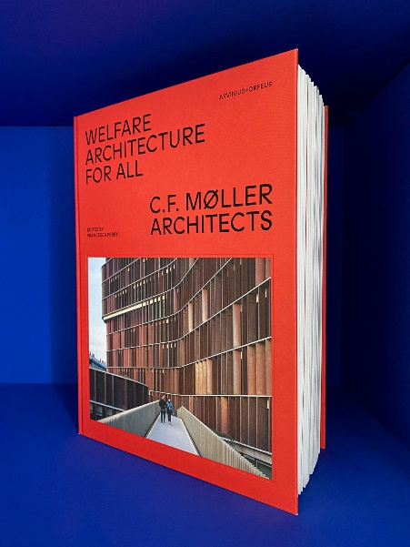
Welfare Architecture for All – new book on welfare architecture from C.F. Møller Architects
C.F. Møller Architects’s work with welfare architecture is presented in a new monography edited by Francesca Perry and published by Arvinius + Orfeus.
C.F. Møller Architects was founded in Denmark in 1924 and has ever since played a significant role in delivering architecture that prioritises the welfare of society. This engagement is now described in a new in-depth book, called Welfare Architecture for All. The book is published by Stockholm-based Arvinius + Orfeus and edited by London- based Francesca Perry.
In thoughtful essays and beautiful photography, the book illuminates thoughtfully and beautifully the human, holistic and generous approach to architecture that characteriszes C.F. Møller Architects. It unfolds the Scandinavian practice’s most recent projects and by through them tackles today’s biggest themes in architecture and urban design to inspire a new welfare-centric approach in the industry.
“The built fabric of everyday life has the power to help improve that life, as long as people and their welfare are placed at the heart of the design process. That is what C.F. Møller Architects does – and has done for almost 100 years now. Their story weaves into a rich history of a welfare society in Denmark that seeks to serve and support a broad public. It is an inspiring model that we can learn from across the world”, says Francesca Perry, editor Welfare Architecture for All.
A special introduction from Kent Martinussen, CEO, Danish Architecture Center, tells the story of how architecture has helped create and support the welfare society in Denmark and across Scandinavia. Essays from a selection of writers then explore how architecture can help us live, work, learn, heal and move better – as well as how it can help tackle climate degradation – through the lens of C.F. Møller’s ambitious projects.
The book is written in English and has contributions from Julian Weyer, Ellinor Thunberg, Debika Ray, Fiona Shipwright, Lauren Teague, Kent Martinussen and Jim McClelland and graphic design by WAAITT.

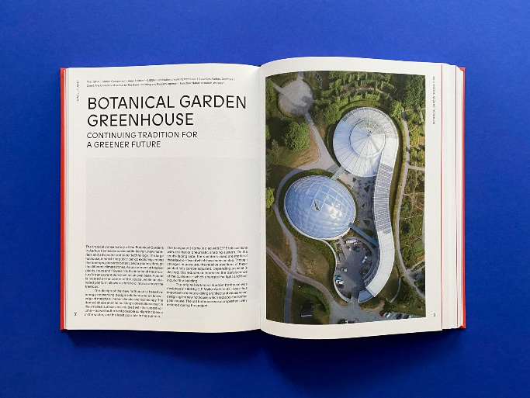
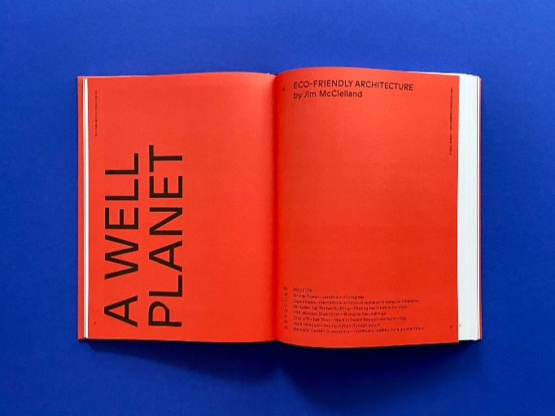
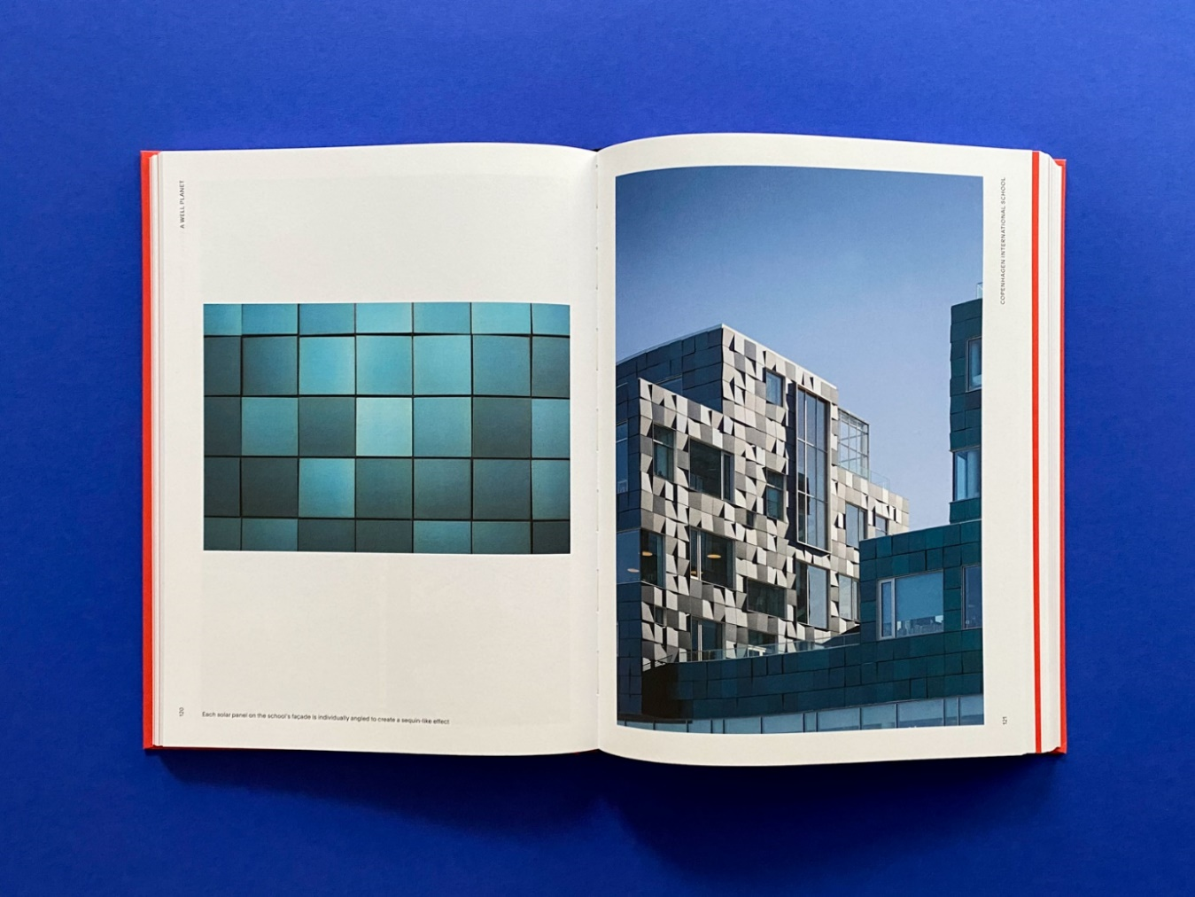
Accessibility
The book can be purchased directly from the publisher via the website, for a recommended price of 58 €.
For more information, please contact:
Peter Sikker
Head of Communications | C.F. Møller Architects
D: +45 6193 6857
E: psr@cfmoller.com

